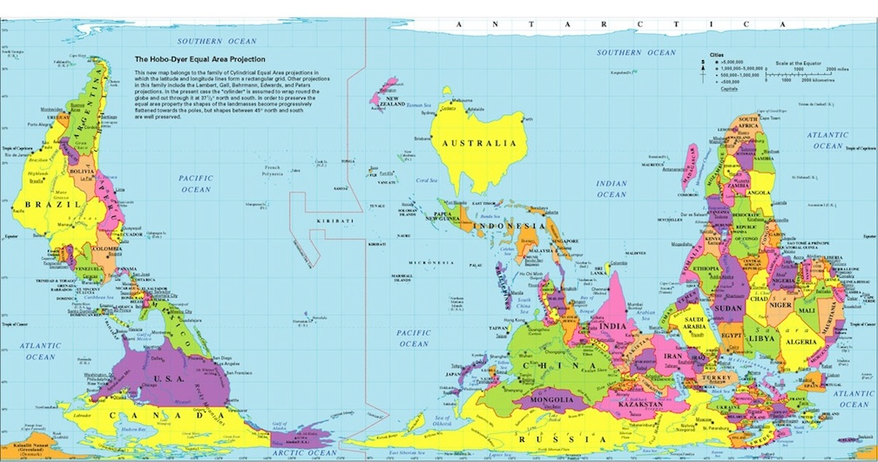
2017-2018 Pre-AP World Geography Course Contract
Welcome to Bowie High School! One of the biggest dilemmas you and your parents will face is whether to take your high school coursework at an Academic level or at a Pre-AP level. If you are passionate about a subject and If you are thinking of accepting the challenge of Pre-Advanced Placement (Pre-AP) World Geography coursework, please consider the following before making your decision:
- Advanced Placement (AP) classes prepare students for the National College Board Advanced Placement exams which allow students to earn college credit if they score well on the test. Students who would like to take AP World History at the sophomore level, AP US History at the junior level, and AP Government/Economics at the senior level are strongly encouraged to take Pre-AP World Geography. Pre-AP World Geography is designed to teach the World Geography standards as well as to prepare highly motivated students for the rigorous and fast paced AP Social Studies courses. This involves a significant amount of reading, writing, and vocabulary acquisition above and beyond what is required of students in Academic World Geography.
- Pre-AP courses are weighted which means that you receive an extra point on your GPA corresponding to the grade you earn in a Pre-AP course. Keep in mind that any grade below 70 is failing regardless of the level of the class and will not earn credit.
- Grades in Pre-AP classes are earned using challenging curriculum. Homework is assigned and is critical to success in understanding concepts. Since the goal of AP classes is test preparation, grades in Pre-AP classes are weighted heavily (70%) on the results of assessments.
- Pre-AP students are expected to be self-starters and take ownership of learning. This means that they must seek out the teacher, either during office hours or during Flexible Instructional Time, when they do not understand a concept or need help acquiring a skill.
- Signs of academic readiness for Pre-AP include:
  - Doing well on STAAR Social Studies, Reading, and Writing tests
  - Doing well in 8th grade English/Language Arts and Social Studies classes
  - Ability to transfer information, make connections, and apply learning to new situations
  - Ability to think critically and to use creativity to problem solve
- Other signs of readiness for Pre-AP include:
  - Responds positively to challenging situations
  - Exhibits a high degree of interest in social studies
  - Highly motivated to learn
  - Exhibits above average maturity in relation to classroom behaviors and to sensitive subject matter

Finally, students should reflect on the following questions before committing to Pre-AP World Geography:
- Do I have an interest in and an aptitude for World Geography?
- Will I be okay making average grades in Pre-AP World Geography even if I am working way harder than I did in middle school? Did I do well on the Reading and Writing STAAR?
- Am I willing to be challenged? What other challenges am I taking on this year?
- How much time in the evenings do I have to do homework? What other classes will I have homework in?

